**Project 2**

**NIFTY 50 Forecasting**

**Abstract**

**NIFTY 50** is a benchmark Indian stock market index that represents the weighted average of top 50 Indian companies listed on the National Stock Exchange. It is one of two main stock indices used in India other being **BSE SENSEX**. Using forecasting future values can be predicted.

**Tools / Skills Used**

1. Python Programming

2. Jupyter Notebook

3. Google Colab

4. Pandas

5. Numpy

6. Matplotlib

7. Seaborn

8. Keras

9. Time Series Forecasting

10. Data Visualization

11. Neural Networks

12. Tableau

**Implementation**

**Workflow:**

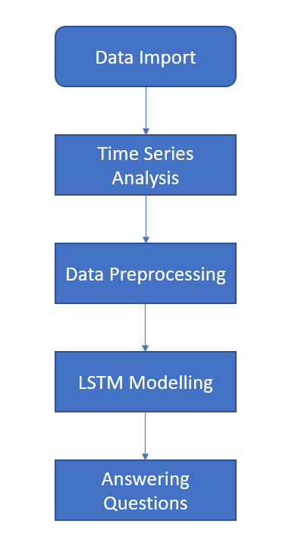

Data Import - In every data science project this is the first step performed. Here we import the data from the desired location into the current working environment.

Time Series Analysis - In this step we plot time series data to see if there is some pattern in the data like

* trend - A market trend is a tendency of the financial market to move in a particular direction.
* Seasonality - In market seasonality is the presence of variations that at specific regular intervals over weeks, months and years.

Data Preprocessing - This is the step after data import where we figure out the anomalies present in the data in the form of missing values, incorrect values etc. and try to deal with it using various techniques like: dropping null values, filling null values using statistical measures i.e. mean, median in case of numerical data and mode in case of categorical data.

LSTM Modelling - LSTM (Long Short-Term Memory) network is a type of recurrent neural network capable of learning order dependency in sequence prediction problems. It is used for complex tasks such as handwriting recognition, speech recognition and anomaly detection.

Answering Questions - After getting the predictions answered some questions which helped in making data driven decisions.

**Code Snippets**

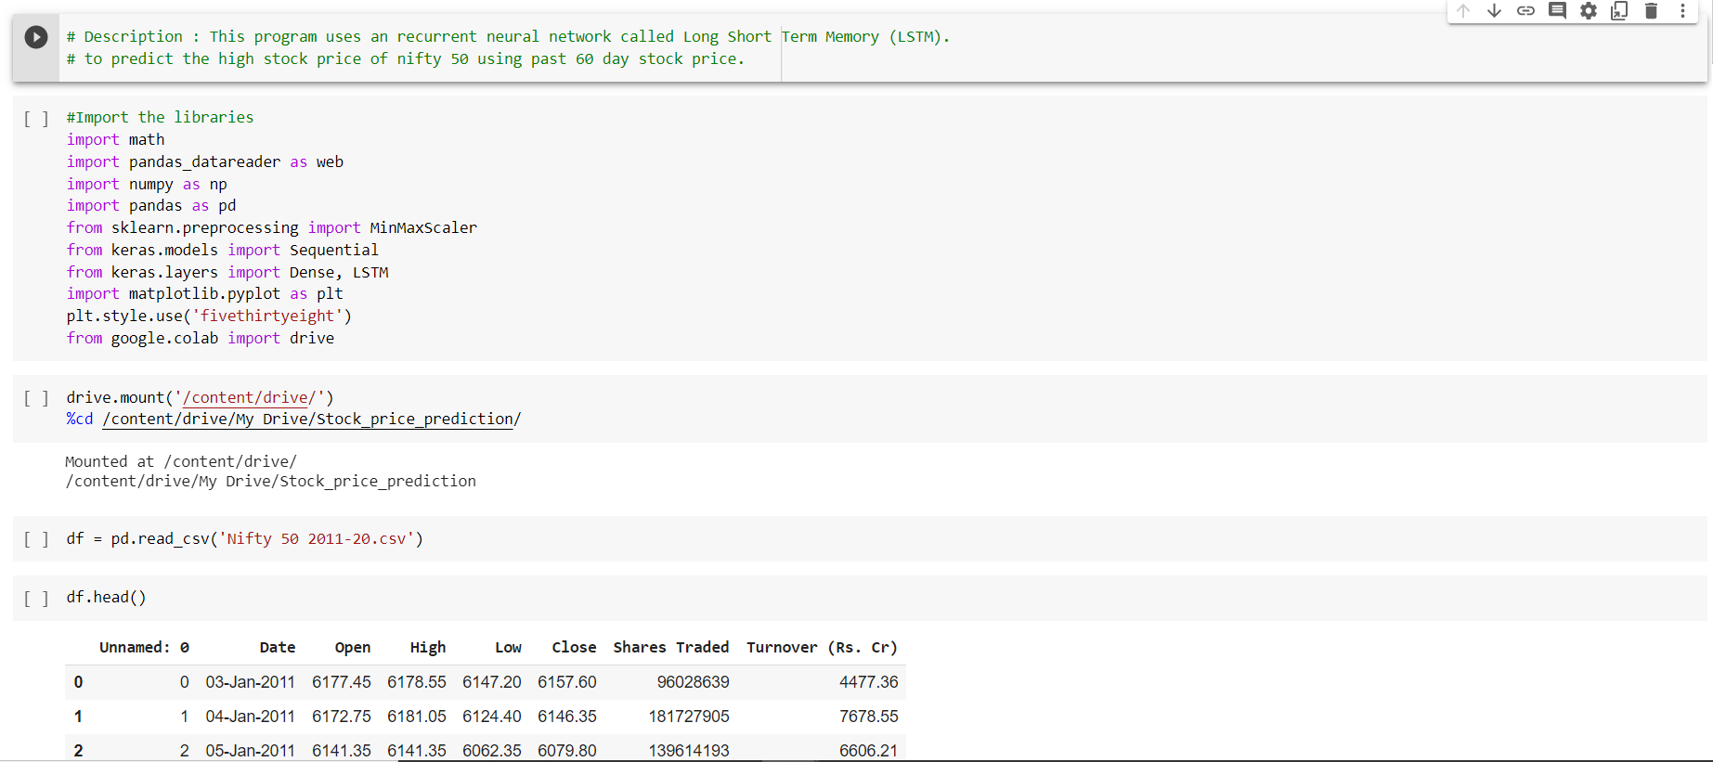

**Time Series Analysis Snippets:**

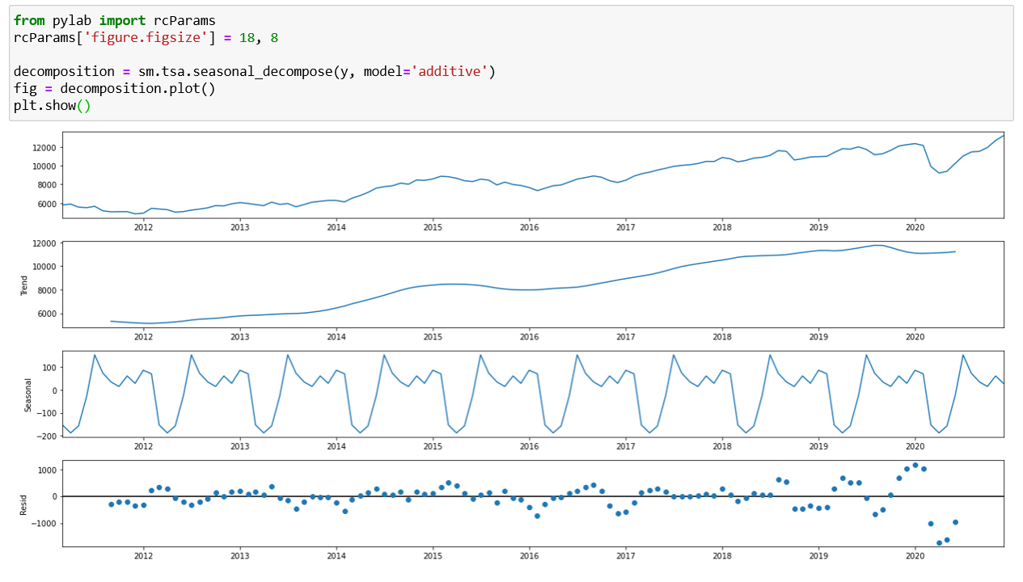

**Data Preprocessing Snippets:**

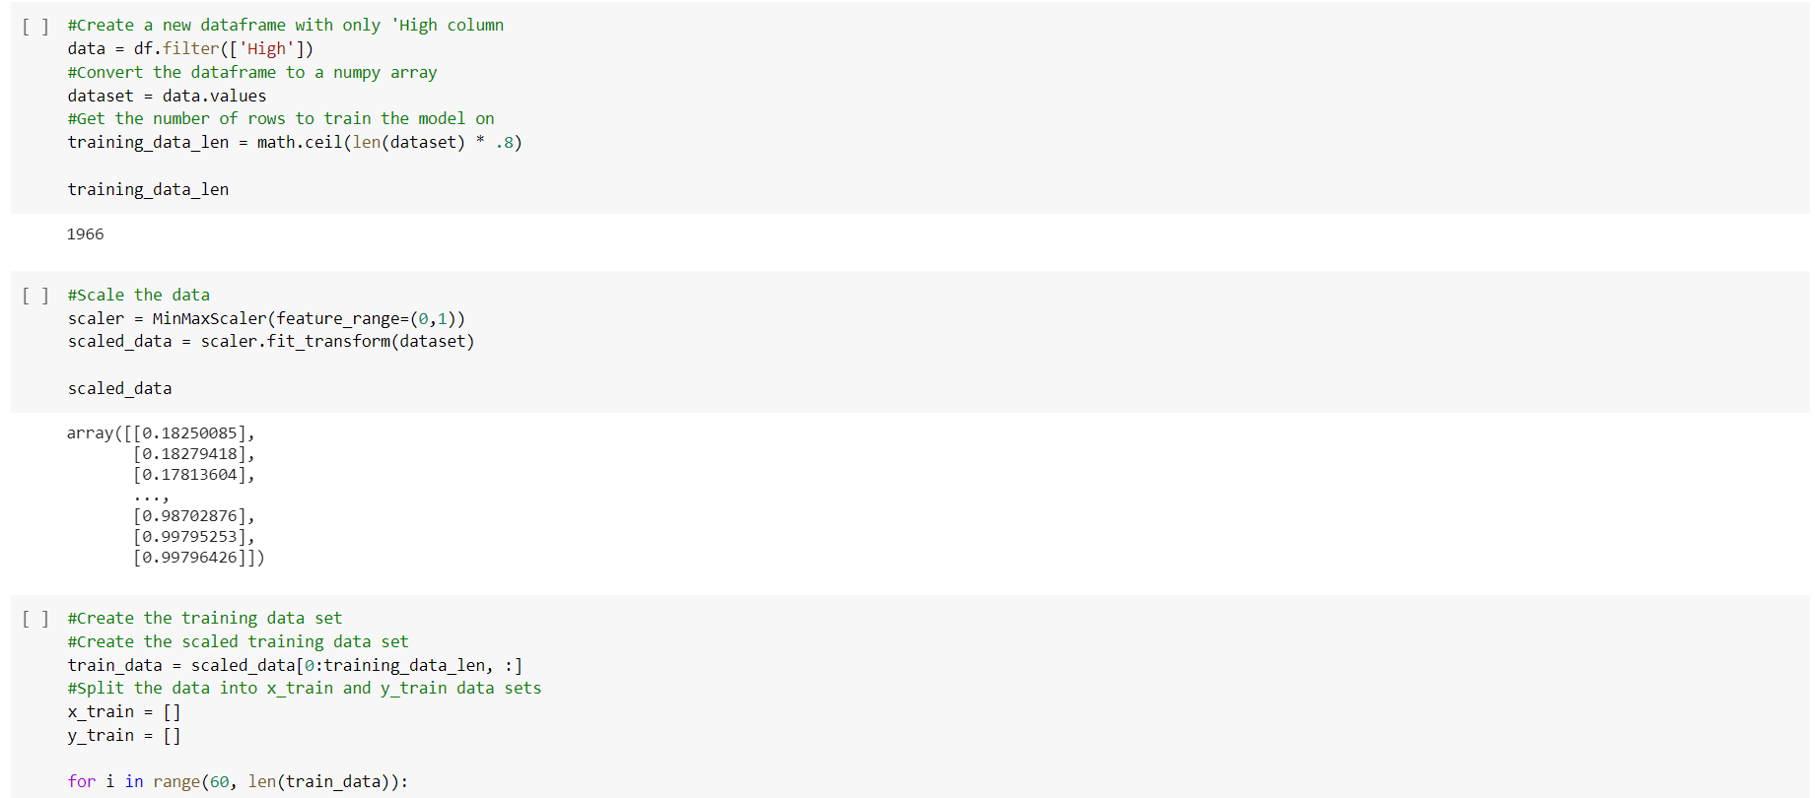

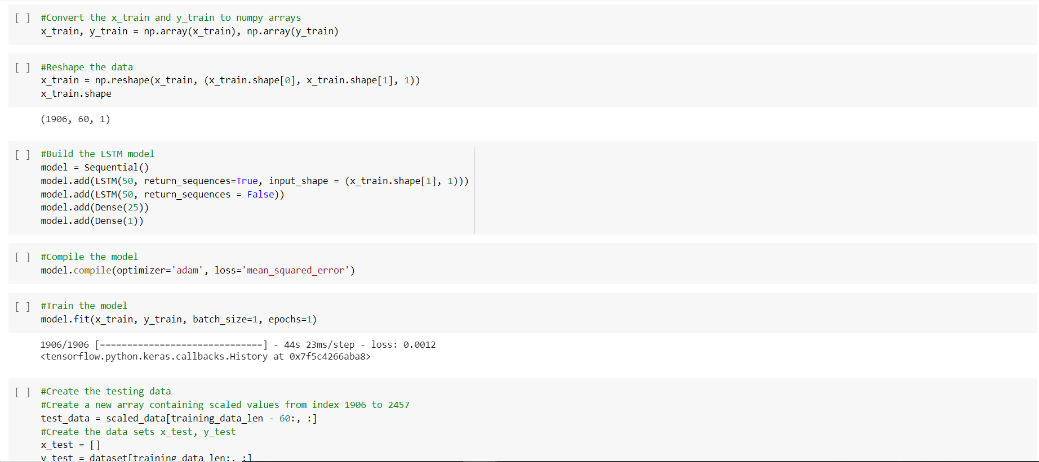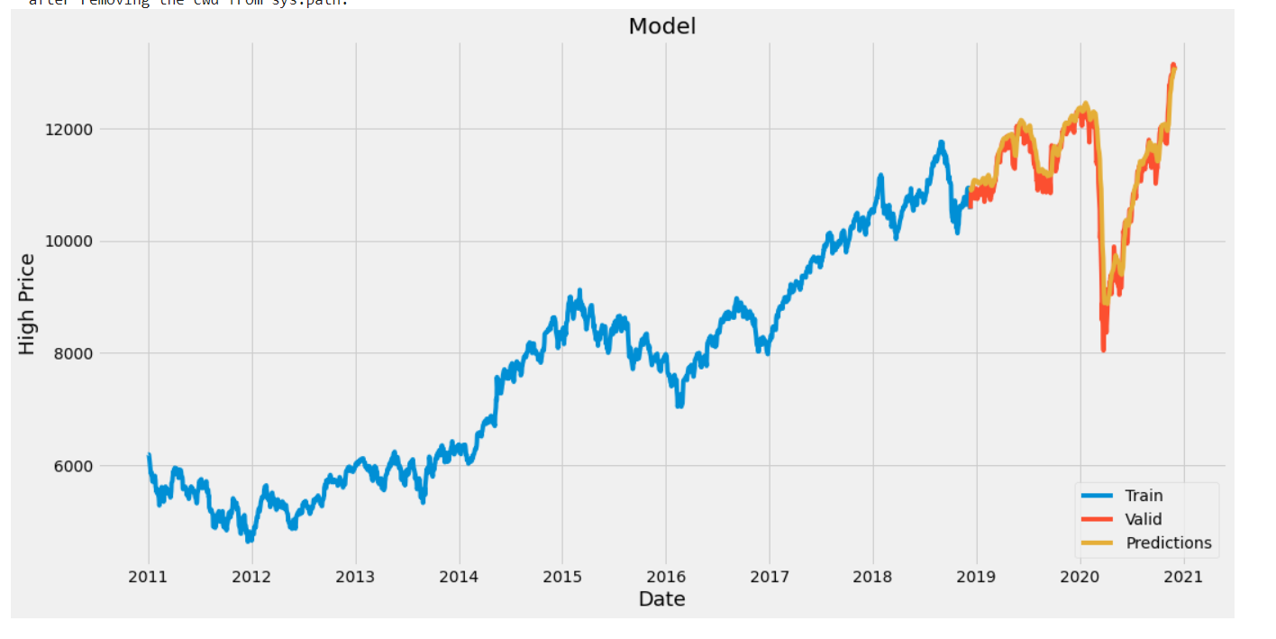

**Questions Snippets:**

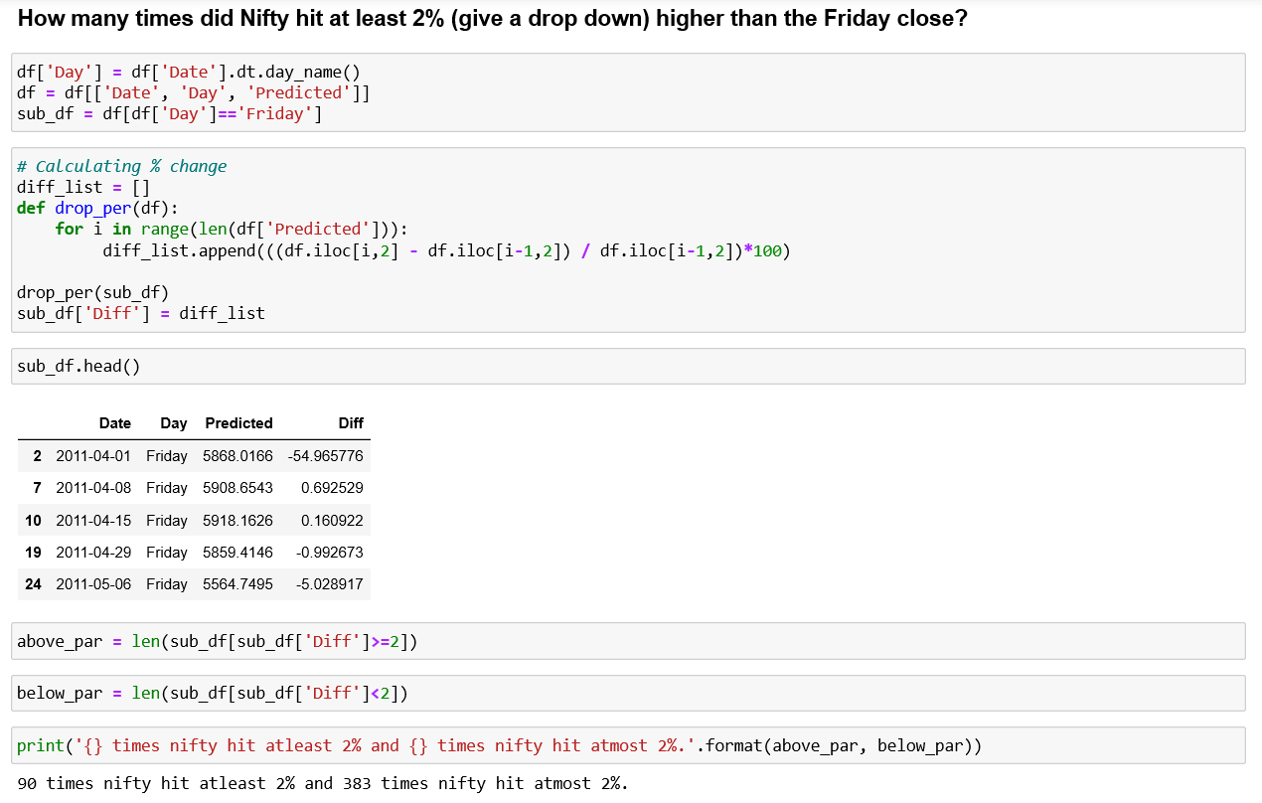

**Tableau Dashboard Snippets:**

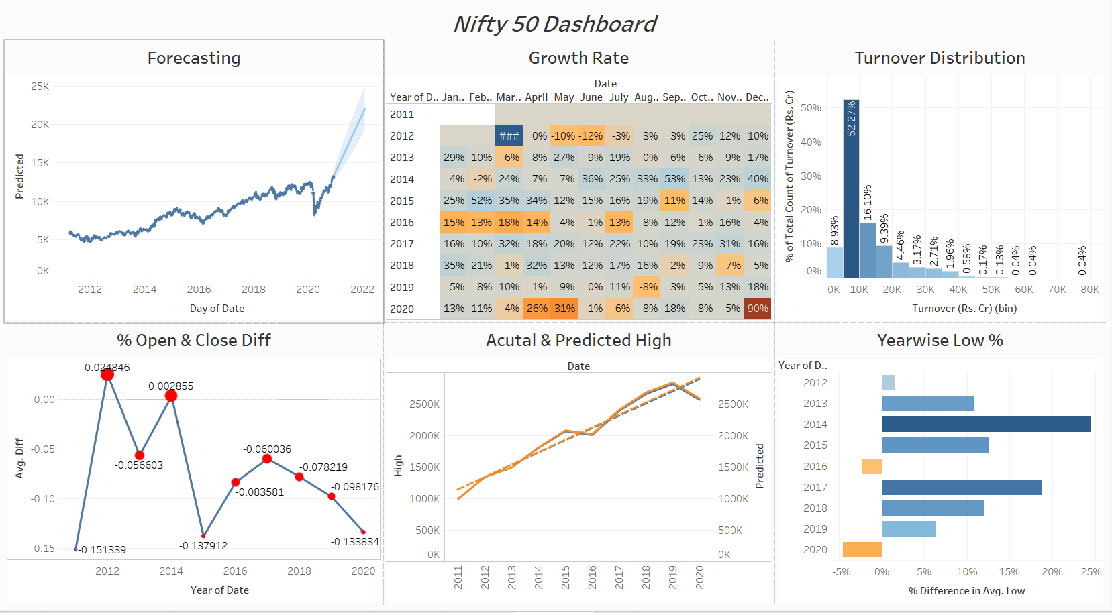

**Conclusion / Results**

As a result, we can say the LSTM model performed well in predicting the forecasted values. Various evaluation metrics like RMSE, MSE can be used to improve the model performance.

**Future Scope**

**NIFTY 50** index depends on various other factors like Market Sentiments, Company news etc. All this can be used for precise forecasting.